BENS - Guide to Using the BENS Framework for YouTube Success
The BENS framework is a powerful tool for crafting titles, thumbnails, and scripts that grab attention and keep viewers engaged. It focuses on four key elements that make your content irresistible.

What is BENS?
BENS is an acronym that stands for:
- Big
- Easy
- New
- Safe
Each element evokes curiosity and builds trust, leading to more clicks, views, and audience retention.

B: Big
Make a bold, attention-grabbing claim.
Viewers are drawn to content that promises a significant result or impact.
Example: 

E: Easy
Make it feel effortless or achievable.
Frame your content as simple and approachable to lower viewer hesitation.
Example: 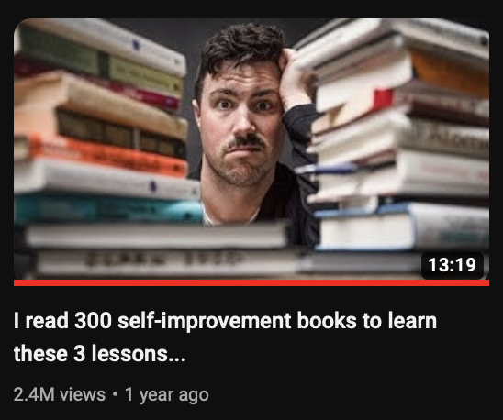

N: New
Offer fresh, unique, or surprising information.
People crave novelty, especially if they've been frustrated by past solutions.
Example: 

S: Safe
Build trust and credibility.
Leverage familiar faces, specific results, or reputable sources to make your content feel reliable.
Example: “

How to Use BENS
- Titles: Combine BENS elements to craft clickable titles.
Example: “Why You’re Losing Money (And How to Fix It in 5 Minutes)”
- Thumbnails: Use visuals and text to amplify curiosity and trust.
Example: A thumbnail showing a graph with “The 3-Step System That Made Me Rich”.
- Scripts: Open with BIG claims, NEW insights, and EASY-to-follow steps. Weave in credibility to make the information feel SAFE.
- Sales copy: In your sales and marketing use BENS to make your offers more interesting, believable and engaging.

Additional Tips
- Specifics Matter: Use numbers, times, or measurable results for credibility.
Example: “How I Made $10,000 in 14 Days” (This is true for titles thumbnail and scripts)
- Create Urgency: Add stakes to titles and scripts to compel immediate action.
Example: “This Mistake Could Cost You $5,000”

Summary
The BENS framework helps your content stand out by making it:
- Big: Meaningful and impactful.
- Easy: Simple and achievable.
- New: Fresh and intriguing.
- Safe: Trustworthy and reliable.
Master these principles, and you’ll make your videos irresistible to your audience.

